**A**

**PROJECT REPORT**

**ON**

**NATIONAL MD**

**Submitted**

**By**

(MDN | Liu Yunpeng, 刘云鹏

Xie Jiahui, 谢家辉

Li ZhiYong 李志勇)

Roll No. | Start Date 2019.5.14

End Date 2019.5.23

 

PROJECT INDEX

|  |  |  |
| --- | --- | --- |
| S no. | Particulars | Page no. |
| 1 | About the National MD requirement, SDLC | 1-2 |
| 2 | About the modules:-  Login module  Register module  FogetPassWord module  ForgetUserName Module | 3-7 |
| 3 | Database table | 08 |
| 4 | Use case Diagram | 09 |
| 5 | DFD of Login Module | 10 |
| 6 | DFD of Register modulr | 11 |
| 7 | DFD of ForgetuserName module | 12 |
| 8 | DFD of FogetPassword module | 13 |
| 9 | **Snapshots**  Login  Register  ForgetUserName  FogetPassWord  Game | 16-17  18  19  20  21-23 |
| 10 | **Source code of** Login  Adventure_game.java  Connective .java  Keep_file.java  Login_in.java  Open.java  Foget password.java  ForgetUsername.java  Regester.java  Welcome.java GamePanel.java  Level.java  LoginPanel.java  MainFrame.java  Base,java  Boom.java  Bot,java  Bullet.java  Level,java  Map.java  Tank.java  Visible.java  Brick.java  Grass wall.java  IRonwall/java  River.java  Wall.java | 24-112 |

TEAM DESCRIPTION & OVERVIEW

Our team is devoted to make a good game

**ACKNOWLEDGEMENT**

**Tanks for the Mr.阿肖克 and MR.Liu’guaindence**

**Flochart**

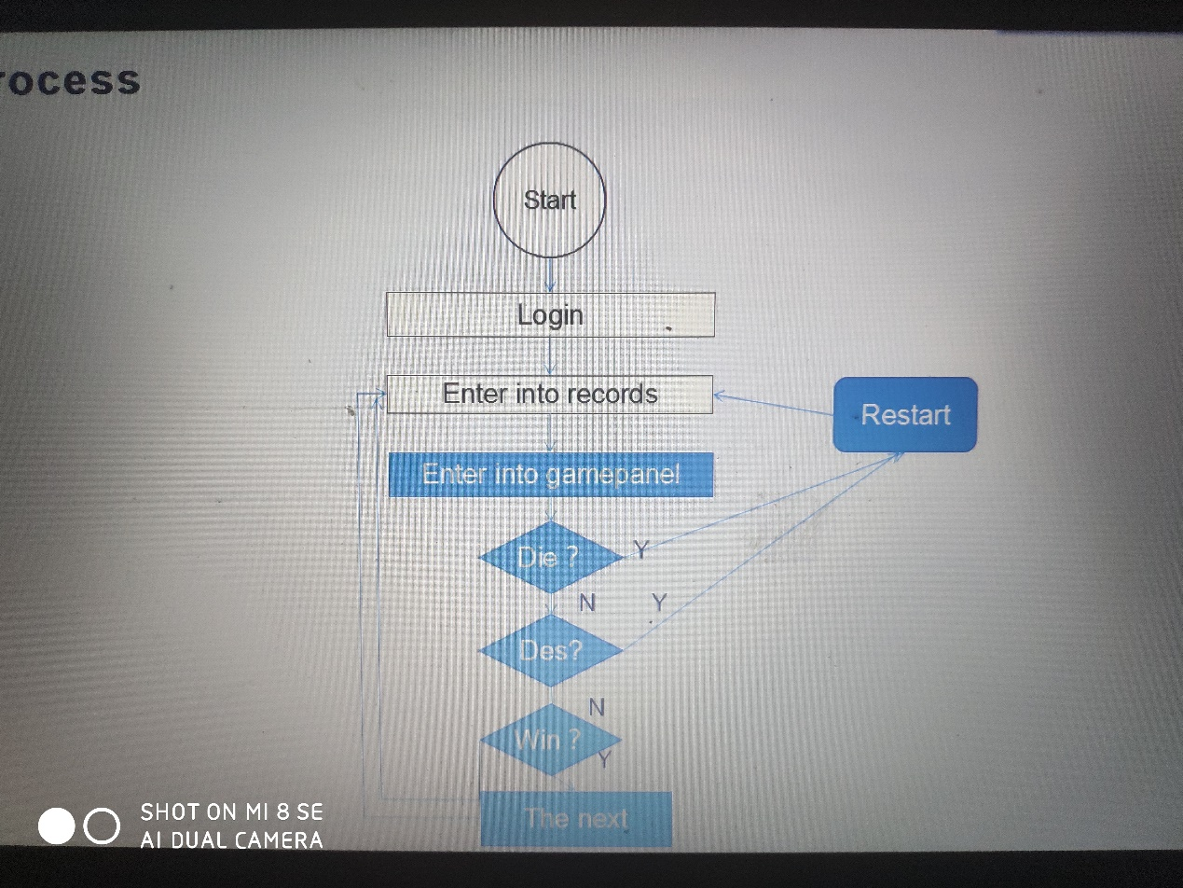

**PROJECT REPORT**

**HUMAN**

**RESOURCE MANAGEMENT**

**SYSTEM //制作原因**

**Software Requirements //软件要求**

* Jdk1.6
* Web Logic Server
* MySql database
* Any IDE like Eclipse3.2 or NetBeans 8.2

.

**SDLC of the Project**

This project is a web application and going to be developed using J2EE technology like servlets, JSP and JDBC similar to all other software projects, this project too has its own software development like cycle. The SDLC of this project will be discussed under the following heads.

**Requirement Analysis //需求分析**

**3**In

**Software Design**

Software design is a solution- “how to approach the creation of a new system”. This important phase is composed of several steps. It provides the understanding and procedural details necessary for implementing the system recommended in the feasibility study.

In software design, there are three distinct types of activities:

* External design
* Architectural design
* Detailed design

**External Design //外部设计**

外部设计  
软件的外部设计包括构思、规划和指定软件产品的外部可观察特征。这些特征包括用户显示、报告格式、外部数据源、功能需求、性能需求和产品的高级流程结构。  
外部设计从分析阶段开始，并在设计阶段继续。

External design of software involves conceiving, planning out and specifying the externally observable characteristics of a software product. These characteristics include user displays, report formats, external data sources, functional requirements , performance requirements and high-level process structure for the product.

External design begins during the analysis phase and continues in the design phase.

**Internal Design //内部设计**

内部设计  
内部设计包括构思、规划和指定软件产品的内部结构和处理细节。内部设计的目标是指定内部结构和处理细节，记录设计决策并指出为什么选择某些替代方案和权衡，详细说明测试计划，并为实现、测试和维护活动提供蓝图。

Internal design involves conceiving, planning out and specifying the internal structure and processing details of the software product. The goals of internal design are to specify internal structure and processing details, to record design decision and indicate why certain alternatives and trade-offs were chosen, to elaborate the test plan, and to provide a blueprint for implementation, testing, and maintenance activities.

**Architectural design //**建筑设计  
体系结构设计涉及细化系统的概念视图、识别内部处理功能、将高级功能分解为子功能、定义内部数据流和数据存储，以及在函数、数据流和数据存储之间建立关系和互连。

Architectural design concerned with refining the conceptual view of the system, identifying internal processing functions, decomposing high-level functions into sub-functions, and defining internal data streams and data stores, and establishing relationships and interconnections among functions, data streams, and data stores.

The software will be designed according to the various modules required to full fill all the requirements uncovered in our requirements analysis. The whole system can be divided into a number of modules. The following modules can be recognized in our project: //软件将根据各种模块进行设计，以充分满足我们在需求分析中发现的所有需求。整个系统可分为多个模块。在我们的项目中可以识别出以下模块:

* Login module
* Register module
* ForgetUsername module
* ForgetPassword module
* Game module
* Leave management module

**Login Module**

This module provides the interface to enter the information for the new player. The information added once can also be edited. All the information regarding the profile of an player is stored. This profile information includes fields like name, the phone number, email, and so on.

**Register Module**

This module is used to add a new user if he or her don’t have a account;It includes the user name, password,phone number ,and your email.

**Forget Username Module**

This module is used to find out your your user name if your forget your user name.If you still remember your phone number and your email .

**Forget password**

This module is used to find your password if your password.You can use your email and your phone number to find your phone number

**Recruitment module**

This module deals with the recruitment procedure of the organization. Right from the starting with the applicants’ registration, calling for written test, technical round, HR round and setting the tests for the called candidates, all functions are handled by this module. This module also manage all the test and uploading the results for all rounds. Finally functioning of this module end with the listing of selected candidate who can be issued offer later.

**The game Module**

This module is used to create a game.It contains the most important part in this project .And it have many small part .It will be mentioned in the following part.

**Database Design**

This game aimed to give a better feeling to the player so it use database to record the every player’s information.It is convenient for player to continue the game and choose the levels.So it has a lot of tables .The tables with their column names and data type are as follows.

**All user**

|  |  |  |  |  |
| --- | --- | --- | --- | --- |
| User_ID | User_Name | User_Password | User_Phone | User_Email |
| 1 | Root | 123456 | 13453537634 | 10528918@qq.com |
|  |  |  |  |  |
|  |  |  |  |  |

**The single user**

|  |  |  |
| --- | --- | --- |
| UID | UTIME | ULEVEL |
| 1 | 2019-05-16 06:20:00 | 1 |
|  |  |  |

**Use Case diagram //执行者 用例 关联关系 包含关系 扩展关系 泛化关系**

**Data Flow Diagram:- //数据流程图**

**外部实体 处理 数据存储 数据流**

**DFD of Login module**

Username password

**DFD of register module**

Username Password

Phone Email

**DFD of ForgetUserName module**

Phone Email UserName

Phone Email UserName

**DFD of ForgetPassword**

UserName Password

Phone

UserName

Phone Password

**Development**

After designing the structures of all the modules and database, the project is developed using MVC (model view condoler) architecture. Implementation of this architecture separates the three parts from each other-data, view and business logic and hence they can we developed separately. The view designed using JSP and the logic is embedded in the controller which is nothing but a servlets. In this project, we will be using pure java classes to hold the data. These pure java classes will be having only attributes variables representing corresponding data fields with no methods. The over all development is done and executed with the help of a web server like tomcat

**DEVELOPING A LOGIN MODULE**

The proposed MDN management system is to be used for the manipulation of some data which is of greater importance for any organization and should always be protected from the unauthorized access. The designed login module is being developed to allow only authorized person to access the available interface and links to add, update and search the important data. Every access to the system goes through this module and is forwarded to the authorized section only after the some mission of a valid login name and password

The development of this module includes writing code for the following files

* **Login_in.java**
* **Welcome.java**
* **KeepFile.java**
* **Register.java**
* **Connective.java**
* **Open.java**
* **Adventure_Game.java**

**DEVELOPING FoegetUserName MODULE**

This module can be used to find your username,it’s very useful when you forget username .It help people a lot .Because it can let user to continue the previous game.

* **ForgetUsername.java**

**DEVELOPING FORGETPASSWORD MODULE**

This module can be used to find your Password,it’s very useful when you forget PassWord .It help people a lot .Because it can let user to continue the previous game.

* **ForgetPassWord.java**

**DEVELOPING GAME MODULE**

* **Direction.java**
* **Tank.java**
* **WallType,java**
* **GamePanel.java**
* **Leve.java**
* **LoginPanel.java**
* **MainFrame.java**
* **Base.java**
* **Bot.java**
* **Boom.java**
* **Bullet.java**
* **Level.java**
* **Map.java**
* **Tank.java**
* **VisibleImage.java**
* **Brick.java**
* **Grass.java**
* **Iron.java**
* **RiverWall.java**

**i**

Login in

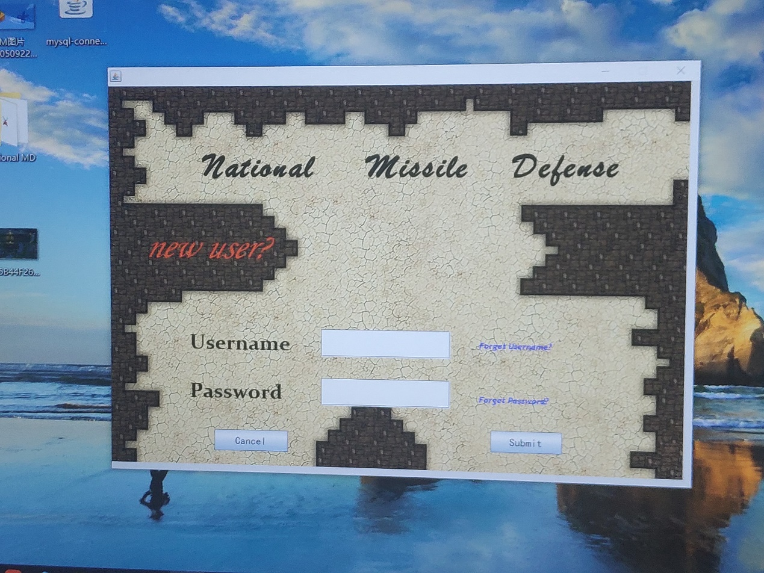

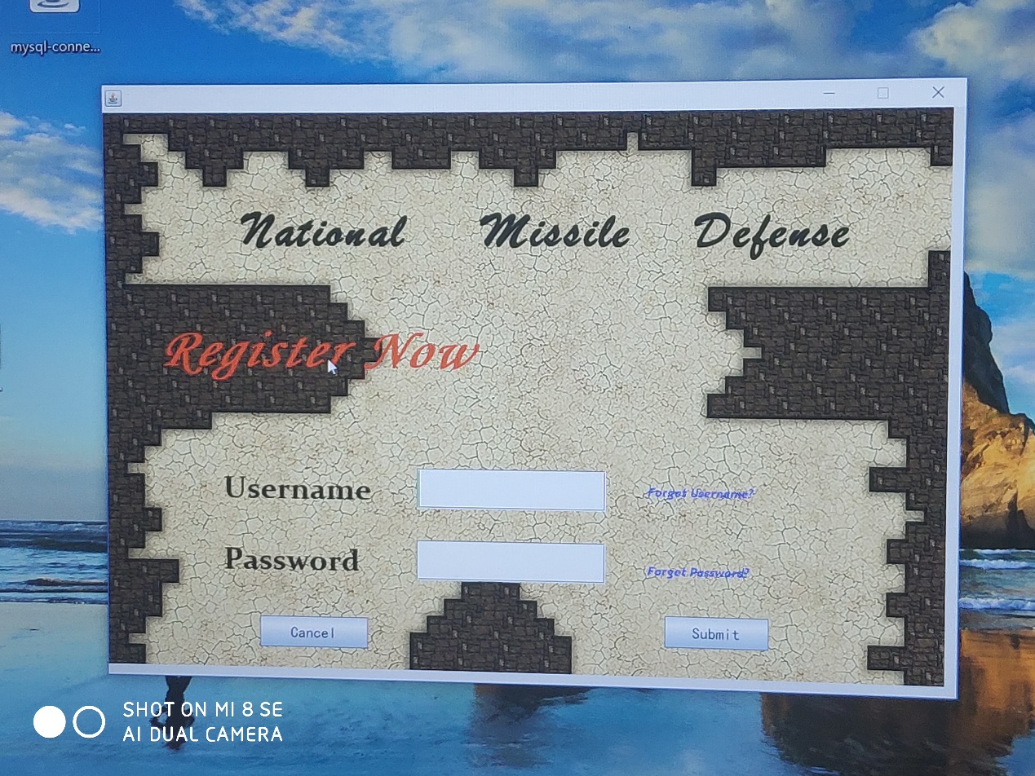

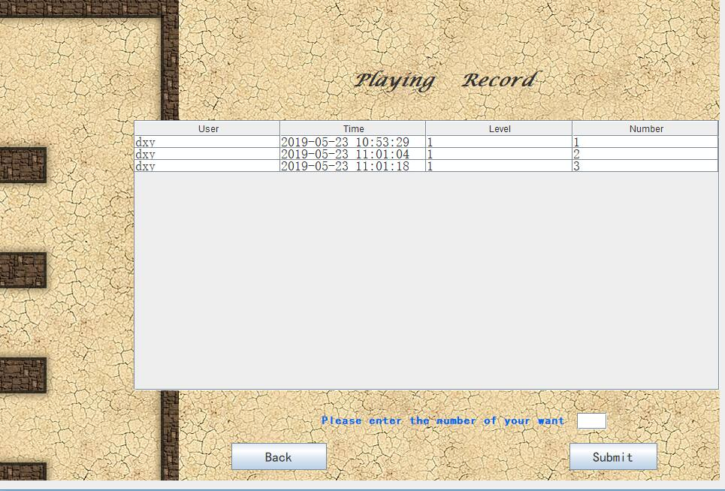

Register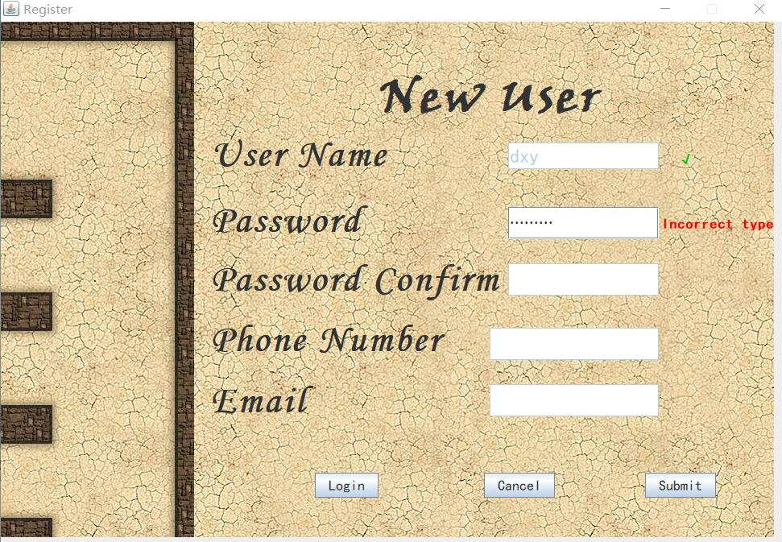

**Forgetpassword**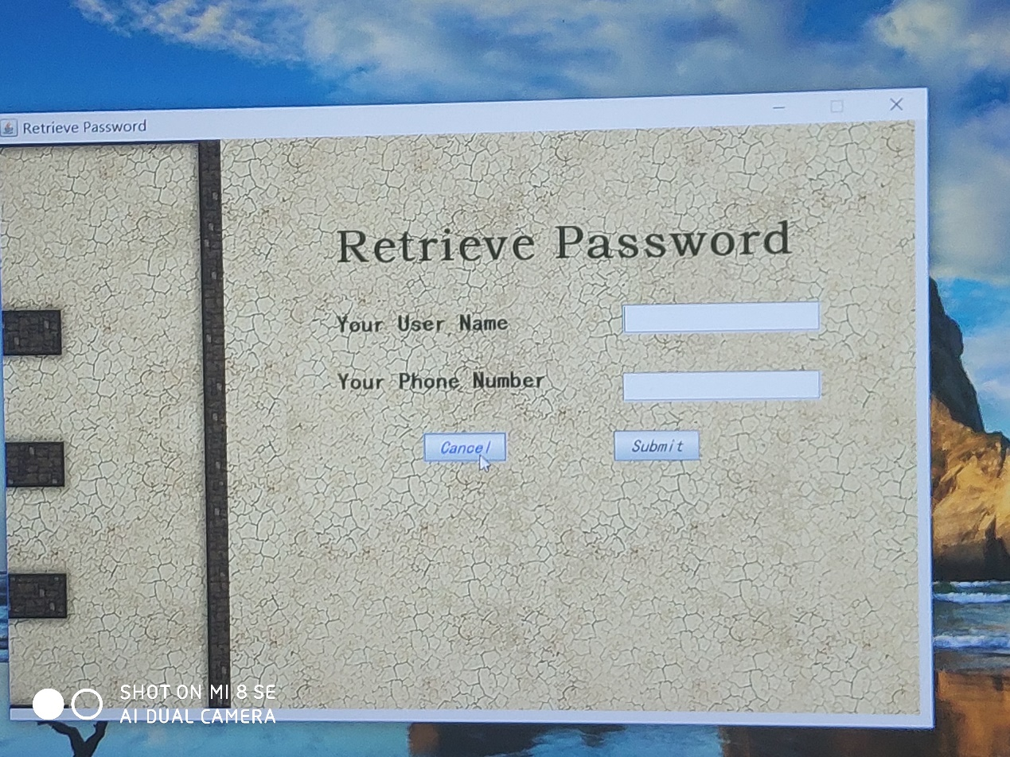

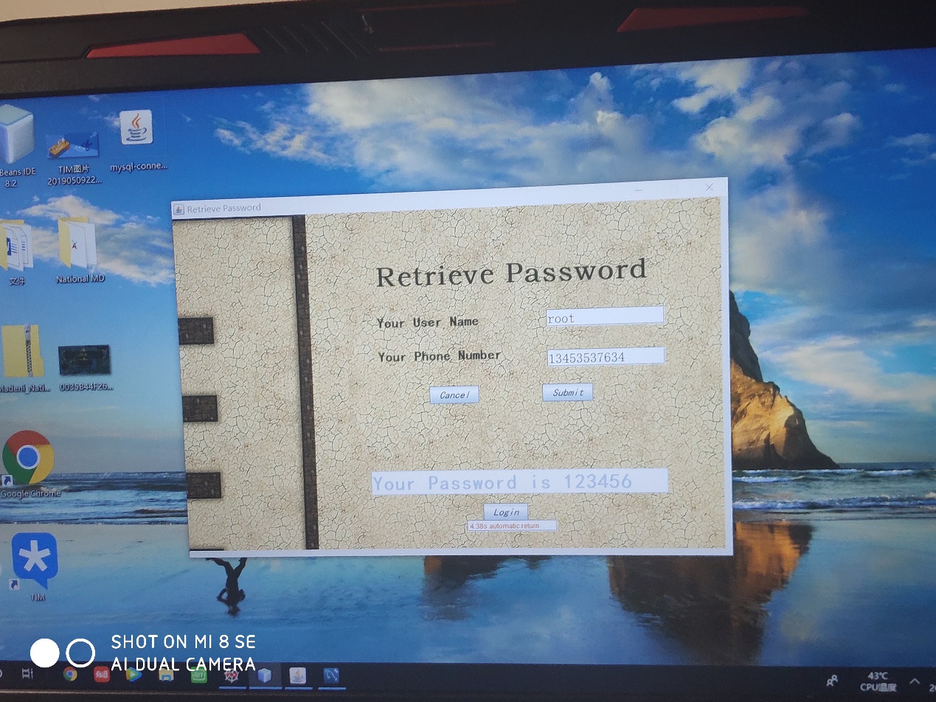

**ForgetUsername**

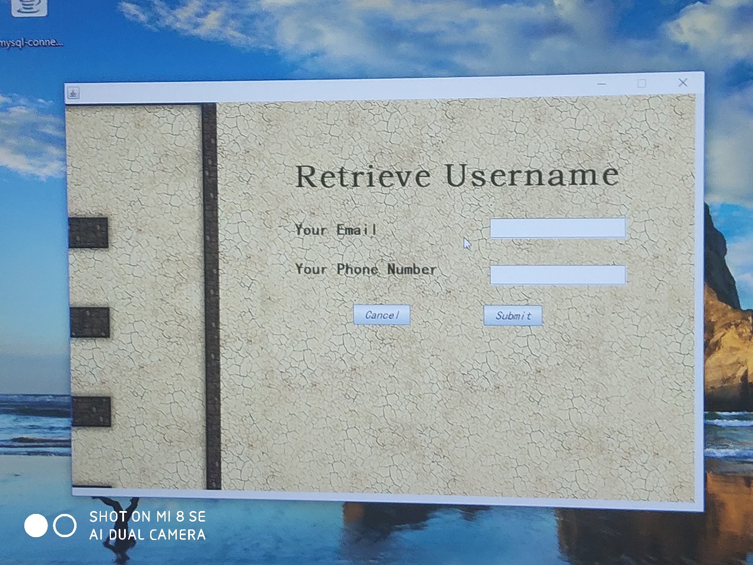

**Game**

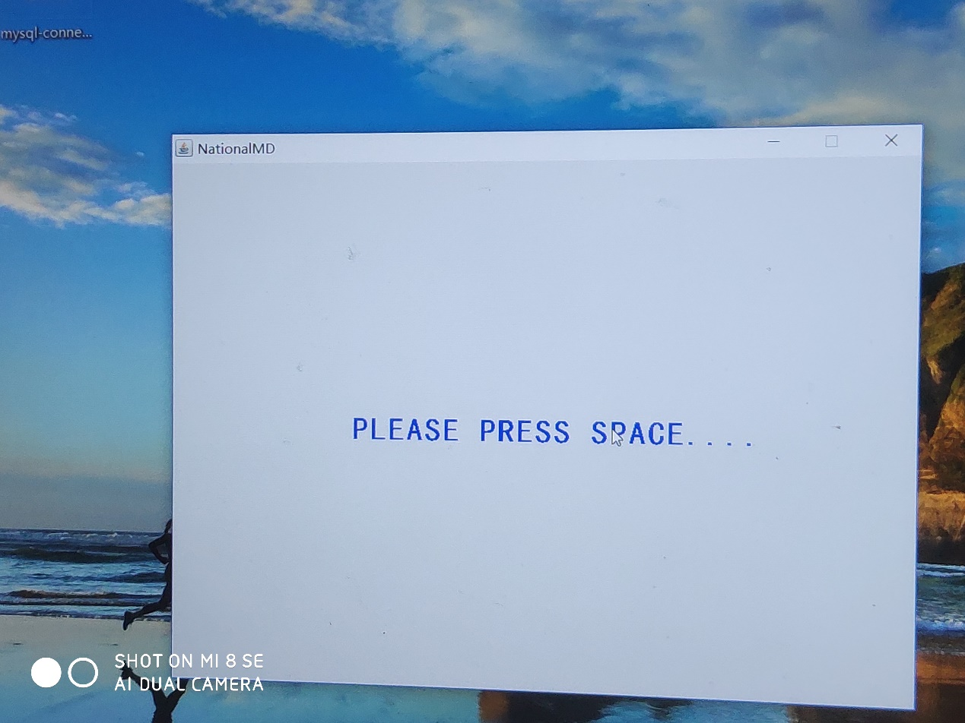

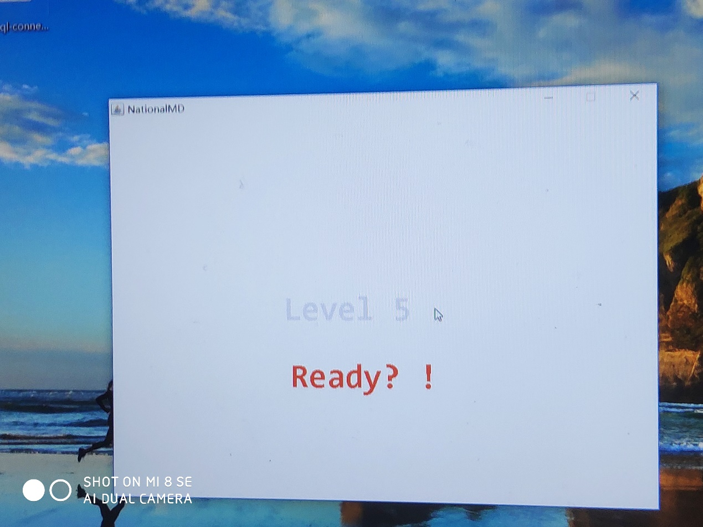

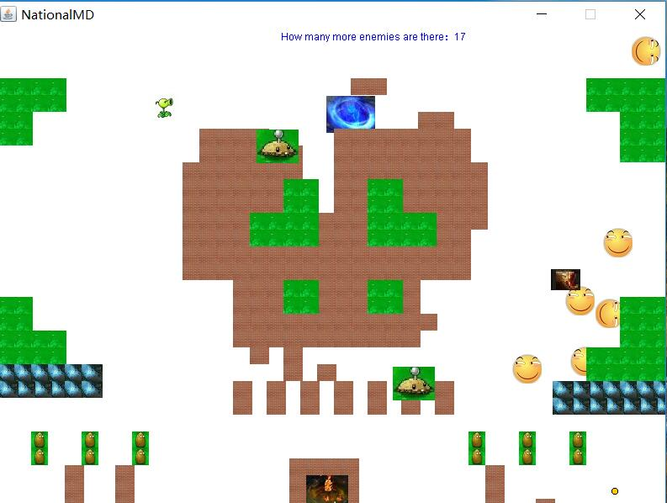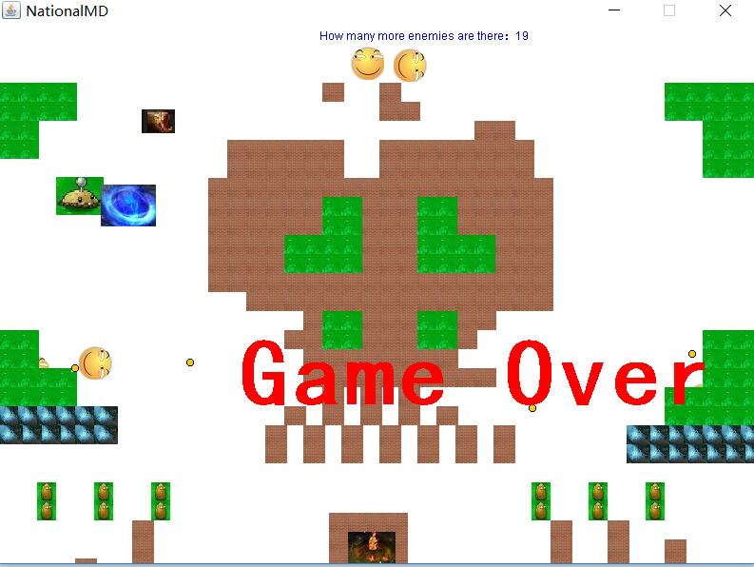

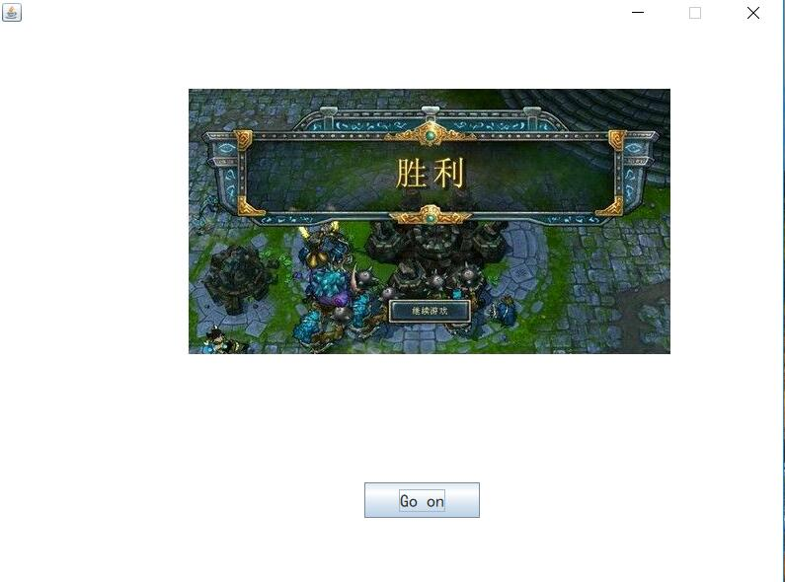

**Login module**

package Login_in;

import java.awt.Color;

import java.awt.Font;

import java.sql.Connection;

import java.sql.PreparedStatement;

import java.sql.ResultSet;

import javax.swing.JOptionPane;

/**

*

* @author 皮皮

*/

public class Login_in extends javax.swing.JFrame {

/**

* Creates new form Login_in

*/

Connection con = null;

PreparedStatement pst;

ResultSet rs;

public String User = null;

public Login_in() {

initComponents();

setResizable(false);

}

public Login_in(String abc) {

initComponents();

jTUsername.setText(abc);

setResizable(false);

}

/**

* This method is called from within the constructor to initialize the form.

* WARNING: Do NOT modify this code. The content of this method is always

* regenerated by the Form Editor.

*/

@SuppressWarnings("unchecked")

// <editor-fold defaultstate="collapsed" desc="Generated Code">

private void initComponents() {

jPanel1 = new javax.swing.JPanel();

jLUN = new javax.swing.JLabel();

jTUsername = new javax.swing.JTextField();

jLNU = new javax.swing.JLabel();

jLUN1 = new javax.swing.JLabel();

jPPassword = new javax.swing.JPasswordField();

jLFP = new javax.swing.JLabel();

Submit = new javax.swing.JButton();

Cancel = new javax.swing.JButton();

jLFP1 = new javax.swing.JLabel();

dsvknlskv = new javax.swing.JLabel();

jLabel2 = new javax.swing.JLabel();

setDefaultCloseOperation(javax.swing.WindowConstants.DISPOSE_ON_CLOSE);

jPanel1.setOpaque(false);

jPanel1.setLayout(new org.netbeans.lib.awtextra.AbsoluteLayout());

jLUN.setFont(new java.awt.Font("Constantia", 1, 36)); // NOI18N

jLUN.setText("Username");

jPanel1.add(jLUN, new org.netbeans.lib.awtextra.AbsoluteConstraints(137, 405, 188, 58));

jTUsername.setFont(new java.awt.Font("Trebuchet MS", 2, 36)); // NOI18N

jPanel1.add(jTUsername, new org.netbeans.lib.awtextra.AbsoluteConstraints(364, 406, 218, -1));

jLNU.setFont(new java.awt.Font("华文隶书", 2, 60)); // NOI18N

jLNU.setForeground(new java.awt.Color(255, 0, 0));

jLNU.setText("new user?");

jLNU.addMouseListener(new java.awt.event.MouseAdapter() {

public void mouseClicked(java.awt.event.MouseEvent evt) {

jLNUMouseClicked(evt);

}

public void mouseEntered(java.awt.event.MouseEvent evt) {

jLNUMouseEntered(evt);

}

public void mouseExited(java.awt.event.MouseEvent evt) {

jLNUMouseExited(evt);

}

});

jPanel1.add(jLNU, new org.netbeans.lib.awtextra.AbsoluteConstraints(60, 230, 460, 82));

jLUN1.setFont(new java.awt.Font("Constantia", 1, 36)); // NOI18N

jLUN1.setText("Password");

jPanel1.add(jLUN1, new org.netbeans.lib.awtextra.AbsoluteConstraints(137, 488, 188, 58));

jPPassword.setFont(new java.awt.Font("宋体", 0, 36)); // NOI18N

jPPassword.addActionListener(new java.awt.event.ActionListener() {

public void actionPerformed(java.awt.event.ActionEvent evt) {

jPPasswordActionPerformed(evt);

}

});

jPanel1.add(jPPassword, new org.netbeans.lib.awtextra.AbsoluteConstraints(364, 489, 218, -1));

jLFP.setFont(new java.awt.Font("Trebuchet MS", 3, 14)); // NOI18N

jLFP.setForeground(new java.awt.Color(51, 51, 255));

jLFP.setText("Forget Password?");

jLFP.addMouseListener(new java.awt.event.MouseAdapter() {

public void mouseClicked(java.awt.event.MouseEvent evt) {

jLFPMouseClicked(evt);

}

public void mouseEntered(java.awt.event.MouseEvent evt) {

jLFPMouseEntered(evt);

}

public void mouseExited(java.awt.event.MouseEvent evt) {

jLFPMouseExited(evt);

}

public void mousePressed(java.awt.event.MouseEvent evt) {

jLFPMousePressed(evt);

}

public void mouseReleased(java.awt.event.MouseEvent evt) {

jLFPMouseReleased(evt);

}

});

jPanel1.add(jLFP, new org.netbeans.lib.awtextra.AbsoluteConstraints(630, 510, -1, -1));

Submit.setFont(new java.awt.Font("黑体", 0, 18)); // NOI18N

Submit.setText("Submit");

Submit.addMouseListener(new java.awt.event.MouseAdapter() {

public void mouseClicked(java.awt.event.MouseEvent evt) {

SubmitMouseClicked(evt);

}

public void mouseEntered(java.awt.event.MouseEvent evt) {

submitMouseEntered(evt);

}

public void mouseExited(java.awt.event.MouseEvent evt) {

SubmitMouseExited(evt);

}

public void mousePressed(java.awt.event.MouseEvent evt) {

submitMousePressed(evt);

}

public void mouseReleased(java.awt.event.MouseEvent evt) {

submitMouseReleased(evt);

}

});

Submit.addActionListener(new java.awt.event.ActionListener() {

public void actionPerformed(java.awt.event.ActionEvent evt) {

SubmitActionPerformed(evt);

}

});

jPanel1.add(Submit, new org.netbeans.lib.awtextra.AbsoluteConstraints(650, 570, 117, 36));

Cancel.setFont(new java.awt.Font("黑体", 0, 18)); // NOI18N

Cancel.setText("Cancel");

Cancel.addMouseListener(new java.awt.event.MouseAdapter() {

public void mouseClicked(java.awt.event.MouseEvent evt) {

cancelMouseClicked(evt);

}

public void mouseEntered(java.awt.event.MouseEvent evt) {

CancelMouseEntered(evt);

}

public void mouseExited(java.awt.event.MouseEvent evt) {

CancelMouseExited(evt);

}

public void mousePressed(java.awt.event.MouseEvent evt) {

cancelMousePressed(evt);

}

public void mouseReleased(java.awt.event.MouseEvent evt) {

cancelMouseReleased(evt);

}

});

Cancel.addKeyListener(new java.awt.event.KeyAdapter() {

public void keyReleased(java.awt.event.KeyEvent evt) {

cancelKeyReleased(evt);

}

});

jPanel1.add(Cancel, new org.netbeans.lib.awtextra.AbsoluteConstraints(180, 580, 127, 36));

jLFP1.setFont(new java.awt.Font("Trebuchet MS", 3, 14)); // NOI18N

jLFP1.setForeground(new java.awt.Color(51, 0, 255));

jLFP1.setText("Forget Username?");

jLFP1.addMouseListener(new java.awt.event.MouseAdapter() {

public void mouseClicked(java.awt.event.MouseEvent evt) {

jLFP1MouseClicked(evt);

}

public void mouseEntered(java.awt.event.MouseEvent evt) {

jLFP1MouseEntered(evt);

}

public void mouseExited(java.awt.event.MouseEvent evt) {

jLFP1MouseExited(evt);

}

public void mousePressed(java.awt.event.MouseEvent evt) {

jLFP1MousePressed(evt);

}

public void mouseReleased(java.awt.event.MouseEvent evt) {

jLFP1MouseReleased(evt);

}

});

jPanel1.add(jLFP1, new org.netbeans.lib.awtextra.AbsoluteConstraints(630, 420, -1, -1));

dsvknlskv.setFont(new java.awt.Font("华文行楷", 1, 60)); // NOI18N

dsvknlskv.setText("National Missile Defense");

dsvknlskv.setToolTipText("National Missile Defense");

jPanel1.add(dsvknlskv, new org.netbeans.lib.awtextra.AbsoluteConstraints(160, 100, 750, 70));

jLabel2.setIcon(new javax.swing.ImageIcon(getClass().getResource("/photo/Cache_26de8fed954b334d..jpg"))); // NOI18N

jLabel2.setVerticalAlignment(javax.swing.SwingConstants.BOTTOM);

jLabel2.setVerticalTextPosition(javax.swing.SwingConstants.BOTTOM);

jPanel1.add(jLabel2, new org.netbeans.lib.awtextra.AbsoluteConstraints(0, 0, 960, 640));

javax.swing.GroupLayout layout = new javax.swing.GroupLayout(getContentPane());

getContentPane().setLayout(layout);

layout.setHorizontalGroup(

layout.createParallelGroup(javax.swing.GroupLayout.Alignment.LEADING)

.addComponent(jPanel1, javax.swing.GroupLayout.PREFERRED_SIZE, 961, javax.swing.GroupLayout.PREFERRED_SIZE)

);

layout.setVerticalGroup(

layout.createParallelGroup(javax.swing.GroupLayout.Alignment.LEADING)

.addComponent(jPanel1, javax.swing.GroupLayout.PREFERRED_SIZE, javax.swing.GroupLayout.DEFAULT_SIZE, javax.swing.GroupLayout.PREFERRED_SIZE)

);

pack();

}// </editor-fold>

private void SubmitActionPerformed(java.awt.event.ActionEvent evt) {

// TODO add your handling code here:

}

private void cancelKeyReleased(java.awt.event.KeyEvent evt) {

// TODO add your handling code here:

}

private void SubmitMouseClicked(java.awt.event.MouseEvent evt) {

try {

con = Connective.getConnection();

String sql = "select * from User_Details where User_name=? and User_password=?";

pst = con.prepareStatement(sql);

pst.setString(1, jTUsername.getText());

pst.setString(2, jPPassword.getText());

rs = pst.executeQuery();

if (jTUsername.getText().length() == 0) {

JOptionPane.showMessageDialog(this, "Empty Username", "Warning", JOptionPane.WARNING_MESSAGE);

} else if (jPPassword.getPassword().length == 0) {

JOptionPane.showMessageDialog(this, "Empty Password", "Warning", JOptionPane.WARNING_MESSAGE);

} else if (rs.next()) {

User = jTUsername.getText();

Open.W(User);

dispose();

} else {

JOptionPane.showMessageDialog(this, "Your Username or password is wrong", "Warning", JOptionPane.WARNING_MESSAGE);

}

rs.close();

pst.close();

con.close();

} catch (Exception e) {

System.out.println(e);

}

}

private void jLFP1MouseClicked(java.awt.event.MouseEvent evt) {

Open.FU();

dispose();

}

private void jLFPMouseClicked(java.awt.event.MouseEvent evt) {

Open.FP();

dispose();

}

private void jLNUMouseClicked(java.awt.event.MouseEvent evt) {

Open.R();

dispose();

// TODO add your handling code here:

;

}

private void cancelMouseClicked(java.awt.event.MouseEvent evt) {

int ans = JOptionPane.showConfirmDialog(this, "Are you so cruel?", "confirm", JOptionPane.YES_NO_CANCEL_OPTION);

if (ans == JOptionPane.YES_OPTION) {

this.dispose();

Open.LI();

}

}

private void jLFPMouseEntered(java.awt.event.MouseEvent evt) {

jLFP.setForeground(Color.red);

jLFP.setFont(new Font("Trebuchet MS", 3, 25));

}

private void jLFP1MouseEntered(java.awt.event.MouseEvent evt) {

jLFP1.setForeground(Color.red);

jLFP1.setFont(new Font("Trebuchet MS", 3, 25));// TODO add your handling code here:

}

private void jLFPMouseExited(java.awt.event.MouseEvent evt) {

jLFP.setFont(new java.awt.Font("Trebuchet MS", 3, 14)); // NOI18N

jLFP.setForeground(new java.awt.Color(51, 51, 255)); // TODO add your handling code here:

}

private void jLFPMousePressed(java.awt.event.MouseEvent evt) {

jLFP.setFont(new java.awt.Font("Trebuchet MS", 3, 27)); // NOI18N

}

private void jLFPMouseReleased(java.awt.event.MouseEvent evt) {

jLFP.setFont(new java.awt.Font("Trebuchet MS", 3, 14)); // NOI18N

jLFP.setForeground(new java.awt.Color(51, 51, 255));

}

private void jLFP1MouseExited(java.awt.event.MouseEvent evt) {

jLFP1.setFont(new java.awt.Font("Trebuchet MS", 3, 14)); // NOI18N

jLFP1.setForeground(new java.awt.Color(51, 51, 255));// TODO add your handling code here:

}

private void jLFP1MousePressed(java.awt.event.MouseEvent evt) {

jLFP.setFont(new java.awt.Font("Trebuchet MS", 3, 27));// TODO add your handling code here:

}

private void jLFP1MouseReleased(java.awt.event.MouseEvent evt) {

jLFP1.setFont(new java.awt.Font("Trebuchet MS", 3, 14)); // NOI18N

jLFP1.setForeground(new java.awt.Color(51, 51, 255));// TODO add your handling code here:

}

private void cancelMousePressed(java.awt.event.MouseEvent evt) {

Cancel.setForeground(Color.red);// TODO add your handling code here:

}

private void submitMouseEntered(java.awt.event.MouseEvent evt) {

Submit.setForeground(Color.blue);// TODO add your handling code here:

// TODO add your handling code here:

}

private void submitMousePressed(java.awt.event.MouseEvent evt) {

Submit.setForeground(Color.red);// TODO add your handling code here:

// TODO add your handling code here:

}

private void submitMouseReleased(java.awt.event.MouseEvent evt) {

Submit.setForeground(null);// TODO add your handling code here:

}

private void cancelMouseReleased(java.awt.event.MouseEvent evt) {

Cancel.setForeground(null);// TODO add your handling code here:

}

private void jLNUMouseEntered(java.awt.event.MouseEvent evt) {

jLNU.setFont(new java.awt.Font("华文隶书", 3, 65)); // NOI18N

jLNU.setText("Register Now");// TODO add your handling code here:

}

private void jLNUMouseExited(java.awt.event.MouseEvent evt) {

jLNU.setFont(new java.awt.Font("华文隶书", 2, 60)); // NOI18N

jLNU.setForeground(new java.awt.Color(255, 0, 0));

jLNU.setText("new user?");// TODO add your handling code here:

}

private void jPPasswordActionPerformed(java.awt.event.ActionEvent evt) {

// TODO add your handling code here:

}

private void SubmitMouseExited(java.awt.event.MouseEvent evt) {

Submit.setForeground(null);// TODO add your handling code here:

// TODO add your handling code here:

}

private void CancelMouseEntered(java.awt.event.MouseEvent evt) {

Cancel.setForeground(Color.blue);// TODO add your handling code here:

// TODO add your handling code here:

}

private void CancelMouseExited(java.awt.event.MouseEvent evt) {

Cancel.setForeground(null);// TODO add your handling code here:

// TODO add your handling code here:

}

/**

* @param args the command line arguments

*/

public static void main(String args[]) {

/*

* Set the Nimbus look and feel

*/

//<editor-fold defaultstate="collapsed" desc=" Look and feel setting code (optional) ">

/*

* If Nimbus (introduced in Java SE 6) is not available, stay with the

* default look and feel. For details see

* http://download.oracle.com/javase/tutorial/uiswing/lookandfeel/plaf.html

*/

try {

for (javax.swing.UIManager.LookAndFeelInfo info : javax.swing.UIManager.getInstalledLookAndFeels()) {

if ("Nimbus".equals(info.getName())) {

javax.swing.UIManager.setLookAndFeel(info.getClassName());

break;

}

}

} catch (ClassNotFoundException ex) {

java.util.logging.Logger.getLogger(Login_in.class.getName()).log(java.util.logging.Level.SEVERE, null, ex);

} catch (InstantiationException ex) {

java.util.logging.Logger.getLogger(Login_in.class.getName()).log(java.util.logging.Level.SEVERE, null, ex);

} catch (IllegalAccessException ex) {

java.util.logging.Logger.getLogger(Login_in.class.getName()).log(java.util.logging.Level.SEVERE, null, ex);

} catch (javax.swing.UnsupportedLookAndFeelException ex) {

java.util.logging.Logger.getLogger(Login_in.class.getName()).log(java.util.logging.Level.SEVERE, null, ex);

}

//</editor-fold>

/*

* Create and display the form

*/

java.awt.EventQueue.invokeLater(new Runnable() {

@Override

public void run() {

new Login_in().setVisible(true);

}

});

}

// Variables declaration - do not modify

private javax.swing.JButton Cancel;

private javax.swing.JButton Submit;

private javax.swing.JLabel dsvknlskv;

private javax.swing.JLabel jLFP;

private javax.swing.JLabel jLFP1;

private javax.swing.JLabel jLNU;

private javax.swing.JLabel jLUN;

private javax.swing.JLabel jLUN1;

private javax.swing.JLabel jLabel2;

private javax.swing.JPasswordField jPPassword;

private javax.swing.JPanel jPanel1;

private javax.swing.JTextField jTUsername;

**Open.javapackage Login_in;**

**i**mport javax.swing.JFrame;

/**

*

* @author 皮皮

*/

public class Open {

public static void KF( ){

Keep_file keep_file = new Keep_file();

keep_file.setLocationRelativeTo(null);

keep_file.setVisible(true);

}

public static void LI() {

Login_in login_in = new Login_in();

login_in.setLocationRelativeTo(null);

login_in.setVisible(true);

}

public static void LI(String ab) {

Login_in login_in = new Login_in(ab);

login_in.setLocationRelativeTo(null);

login_in.setVisible(true);

}

public static void FP() {

forgetpassword forgetUsername = new forgetpassword();

forgetUsername.setLocationRelativeTo(null);

forgetUsername.setVisible(true);

}

public static void FU() {

forgetusername forgetUsername = new forgetusername();

forgetUsername.setLocationRelativeTo(null);

forgetUsername.setVisible(true);

}

public static void R() {

register register = new register();

register.setLocationRelativeTo(null);

register.setVisible(true);

}

public static void W(String ab) {

welcome register = new welcome(ab);

register.setLocationRelativeTo(null);

register.setVisible(true);

}

}

**Keep_File .java**

package Login_in;

import frame.MainFrame;

import java.awt.Color;

import java.sql.Connection;

import java.sql.PreparedStatement;

import java.sql.ResultSet;

import java.sql.ResultSetMetaData;

import javax.swing.JOptionPane;

import javax.swing.table.DefaultTableModel;

import javax.swing.table.TableColumn;

import javax.swing.table.TableColumnModel;

import static model.Level.setlive;

/**

*

* @author 皮皮

*/

public class Keep_file extends javax.swing.JFrame {

Connection con = null;

PreparedStatement pst;

ResultSet rs;

String user = welcome.User;

Object[][] a = new Object[50][5];

int count = 0;

/**

* Creates new form Keep_file

*/

public Keep_file() {

initComponents();

showkeep();

setResizable(false);

}

/**

* This method is called from within the constructor to initialize the form.

* WARNING: Do NOT modify this code. The content of this method is always

* regenerated by the Form Editor.

*/

@SuppressWarnings("unchecked")

// <editor-fold defaultstate="collapsed" desc="Generated Code">

private void initComponents() {

jPanel1 = new javax.swing.JPanel();

jPanel2 = new javax.swing.JPanel();

jScrollPane1 = new javax.swing.JScrollPane();

JT = new javax.swing.JTable();

jLabel2 = new javax.swing.JLabel();

Cancel = new javax.swing.JButton();

jLabel3 = new javax.swing.JLabel();

JT1 = new javax.swing.JTextField();

Submit = new javax.swing.JButton();

jLabel1 = new javax.swing.JLabel();

setDefaultCloseOperation(javax.swing.WindowConstants.EXIT_ON_CLOSE);

jPanel1.setLayout(new org.netbeans.lib.awtextra.AbsoluteLayout());

jPanel2.setOpaque(false);

jPanel2.setLayout(new org.netbeans.lib.awtextra.AbsoluteLayout());

JT.setFont(new java.awt.Font("宋体", 0, 18)); // NOI18N

JT.setModel(new javax.swing.table.DefaultTableModel(

new Object [][] {

},

new String [] {

"User", "Time", "Level"

}

));

jScrollPane1.setViewportView(JT);

jPanel2.add(jScrollPane1, new org.netbeans.lib.awtextra.AbsoluteConstraints(180, 160, 780, 360));

jLabel2.setFont(new java.awt.Font("Lucida Calligraphy", 3, 24)); // NOI18N

jLabel2.setText("Playing Record");

jPanel2.add(jLabel2, new org.netbeans.lib.awtextra.AbsoluteConstraints(470, 90, 321, -1));

Cancel.setFont(new java.awt.Font("黑体", 0, 18)); // NOI18N

Cancel.setText("Back");

Cancel.addMouseListener(new java.awt.event.MouseAdapter() {

public void mouseClicked(java.awt.event.MouseEvent evt) {

CancelcancelMouseClicked(evt);

}

public void mouseEntered(java.awt.event.MouseEvent evt) {

CancelMouseEntered(evt);

}

public void mouseExited(java.awt.event.MouseEvent evt) {

CancelMouseExited(evt);

}

public void mousePressed(java.awt.event.MouseEvent evt) {

CancelcancelMousePressed(evt);

}

public void mouseReleased(java.awt.event.MouseEvent evt) {

CancelcancelMouseReleased(evt);

}

});

Cancel.addKeyListener(new java.awt.event.KeyAdapter() {

public void keyReleased(java.awt.event.KeyEvent evt) {

CancelcancelKeyReleased(evt);

}

});

jPanel2.add(Cancel, new org.netbeans.lib.awtextra.AbsoluteConstraints(310, 590, 127, 36));

jLabel3.setFont(new java.awt.Font("黑体", 1, 15)); // NOI18N

jLabel3.setForeground(new java.awt.Color(0, 102, 255));

jLabel3.setText("Please enter the number of your want ");

jPanel2.add(jLabel3, new org.netbeans.lib.awtextra.AbsoluteConstraints(430, 550, -1, 20));

JT1.setFont(new java.awt.Font("黑体", 1, 15)); // NOI18N

jPanel2.add(JT1, new org.netbeans.lib.awtextra.AbsoluteConstraints(770, 550, 40, -1));

Submit.setFont(new java.awt.Font("黑体", 0, 18)); // NOI18N

Submit.setText("Submit");

Submit.addMouseListener(new java.awt.event.MouseAdapter() {

public void mouseClicked(java.awt.event.MouseEvent evt) {

SubmitMouseClicked(evt);

}

public void mouseEntered(java.awt.event.MouseEvent evt) {

SubmitsubmitMouseEntered(evt);

}

public void mouseExited(java.awt.event.MouseEvent evt) {

SubmitMouseExited(evt);

}

public void mousePressed(java.awt.event.MouseEvent evt) {

SubmitsubmitMousePressed(evt);

}

public void mouseReleased(java.awt.event.MouseEvent evt) {

SubmitsubmitMouseReleased(evt);

}

});

Submit.addActionListener(new java.awt.event.ActionListener() {

public void actionPerformed(java.awt.event.ActionEvent evt) {

SubmitActionPerformed(evt);

}

});

jPanel2.add(Submit, new org.netbeans.lib.awtextra.AbsoluteConstraints(760, 590, 117, 36));

jPanel1.add(jPanel2, new org.netbeans.lib.awtextra.AbsoluteConstraints(0, 0, 960, 640));

jLabel1.setIcon(new javax.swing.ImageIcon(getClass().getResource("/photo/Cache_-2e8a9f2d6617e3c1..jpg"))); // NOI18N

jPanel1.add(jLabel1, new org.netbeans.lib.awtextra.AbsoluteConstraints(0, 0, -1, -1));

javax.swing.GroupLayout layout = new javax.swing.GroupLayout(getContentPane());

getContentPane().setLayout(layout);

layout.setHorizontalGroup(

layout.createParallelGroup(javax.swing.GroupLayout.Alignment.LEADING)

.addComponent(jPanel1, javax.swing.GroupLayout.DEFAULT_SIZE, javax.swing.GroupLayout.DEFAULT_SIZE, Short.MAX_VALUE)

);

layout.setVerticalGroup(

layout.createParallelGroup(javax.swing.GroupLayout.Alignment.LEADING)

.addComponent(jPanel1, javax.swing.GroupLayout.PREFERRED_SIZE, javax.swing.GroupLayout.DEFAULT_SIZE, javax.swing.GroupLayout.PREFERRED_SIZE)

);

pack();

}// </editor-fold>

private void CancelcancelMouseClicked(java.awt.event.MouseEvent evt) {

welcome welcome = new welcome(user);

welcome.setLocationRelativeTo(this);

welcome.setVisible(true);

dispose();

}

private void CancelMouseEntered(java.awt.event.MouseEvent evt) {

Cancel.setForeground(Color.blue);// TODO add your handling code here:

// TODO add your handling code here:

}

private void CancelMouseExited(java.awt.event.MouseEvent evt) {

Cancel.setForeground(null);// TODO add your handling code here:

// TODO add your handling code here:

}

private void CancelcancelMousePressed(java.awt.event.MouseEvent evt) {

Cancel.setForeground(Color.red);// TODO add your handling code here:

}

private void CancelcancelMouseReleased(java.awt.event.MouseEvent evt) {

Cancel.setForeground(null);// TODO add your handling code here:

}

private void CancelcancelKeyReleased(java.awt.event.KeyEvent evt) {

// TODO add your handling code here:

}

private void SubmitMouseClicked(java.awt.event.MouseEvent evt) {

if (JT1.getText().length() == 0) {

JOptionPane.showMessageDialog(this, "You have not enter.", "Warning", JOptionPane.WARNING_MESSAGE);

} else if (Integer.parseInt(JT1.getText()) < 1 || Integer.parseInt(JT1.getText()) > count) {

JOptionPane.showMessageDialog(this, "Your input is incorrect.", "Warning", JOptionPane.WARNING_MESSAGE);

} else {

for (int x = 0; x < count; x++) {

if (Integer.parseInt(JT1.getText()) == Integer.parseInt(a[x][3].toString())) {

setlive(Integer.parseInt(a[x][2].toString()));

try {

con = new Connective().getConnection();

String sql = "delete from " + user + " where ID = ?";

pst = con.prepareStatement(sql);

pst.setInt(1, Integer.parseInt((String) a[x][4]));

pst.executeUpdate();

pst.close();

con.close();

dispose();

} catch (Exception ex) {

System.out.println(ex);

}

MainFrame frame = new MainFrame();

frame.setVisible(true);

}

}

}

}

private void SubmitsubmitMouseEntered(java.awt.event.MouseEvent evt) {

Submit.setForeground(Color.blue);// TODO add your handling code here:

// TODO add your handling code here:

}

private void SubmitMouseExited(java.awt.event.MouseEvent evt) {

Submit.setForeground(null);// TODO add your handling code here:

// TODO add your handling code here:

}

private void SubmitsubmitMousePressed(java.awt.event.MouseEvent evt) {

Submit.setForeground(Color.red);// TODO add your handling code here:

// TODO add your handling code here:

}

private void SubmitsubmitMouseReleased(java.awt.event.MouseEvent evt) {

Submit.setForeground(null);// TODO add your handling code here:

}

private void SubmitActionPerformed(java.awt.event.ActionEvent evt) {

// TODO add your handling code here:

}

/**

* @param args the command line arguments

*/

public static void main(String args[]) {

/* Set the Nimbus look and feel */

//<editor-fold defaultstate="collapsed" desc=" Look and feel setting code (optional) ">

/* If Nimbus (introduced in Java SE 6) is not available, stay with the default look and feel.

* For details see http://download.oracle.com/javase/tutorial/uiswing/lookandfeel/plaf.html

*/

try {

for (javax.swing.UIManager.LookAndFeelInfo info : javax.swing.UIManager.getInstalledLookAndFeels()) {

if ("Nimbus".equals(info.getName())) {

javax.swing.UIManager.setLookAndFeel(info.getClassName());

break;

}

}

} catch (ClassNotFoundException ex) {

java.util.logging.Logger.getLogger(Keep_file.class.getName()).log(java.util.logging.Level.SEVERE, null, ex);

} catch (InstantiationException ex) {

java.util.logging.Logger.getLogger(Keep_file.class.getName()).log(java.util.logging.Level.SEVERE, null, ex);

} catch (IllegalAccessException ex) {

java.util.logging.Logger.getLogger(Keep_file.class.getName()).log(java.util.logging.Level.SEVERE, null, ex);

} catch (javax.swing.UnsupportedLookAndFeelException ex) {

java.util.logging.Logger.getLogger(Keep_file.class.getName()).log(java.util.logging.Level.SEVERE, null, ex);

}

//</editor-fold>

/* Create and display the form */

java.awt.EventQueue.invokeLater(new Runnable() {

public void run() {

new Keep_file().setVisible(true);

}

});

}

@SuppressWarnings("empty-statement")

private void showkeep() {

try {

con = new Connective().getConnection();

String sql = "select Date_format(Utime,'%Y-%m-%d %T'),Ulevel,ID from " + user;

pst = con.prepareStatement(sql);

rs = pst.executeQuery();

ResultSetMetaData rsmd = rs.getMetaData();

DefaultTableModel tm = (DefaultTableModel) JT.getModel();

tm.addColumn("Number");

int i = 1;

for (int j = 0; rs.next(); j++, i++) {

for (int s = 1; s < 3; s++) {

a[j][0] = user;

a[j][s] = rs.getString(s);

a[j][3] = j + 1;

}

tm.addRow(a[j]);

a[j][4] = rs.getString(3);

count = j + 1;

}

tm.fireTableDataChanged();

rs.close();

pst.close();

con.close();

} catch (Exception ex) {

System.out.println(ex);

}

}

// Variables declaration - do not modify

private javax.swing.JButton Cancel;

private javax.swing.JTable JT;

private javax.swing.JTextField JT1;

private javax.swing.JButton Submit;

private javax.swing.JLabel jLabel1;

private javax.swing.JLabel jLabel2;

private javax.swing.JLabel jLabel3;

private javax.swing.JPanel jPanel1;

private javax.swing.JPanel jPanel2;

private javax.swing.JScrollPane jScrollPane1;

// End of variables declaration

}

Connective.java

package Login_in;

import java.sql.DriverManager;

import java.sql.SQLException;

public class Connective {

public static java.sql.Connection getConnection() throws SQLException, ClassNotFoundException{

String driver ="com.mysql.jdbc.Driver";

String url="jdbc:mysql://localhost:3306/Game";

String password="123456";

String user="root";

Class.forName(driver);

return DriverManager.getConnection(url, user, password);

// System.out.println("完成");

}

}

Adventure_game

package Login_in;

public class Adventure_game {

public static void main(String[] args) {

Login_in login_in = new Login_in();

login_in.setLocationRelativeTo(null);

login_in.setVisible(true);

}

}

**FogetUserName.java**

import com.mysql.jdbc.Connection;

import java.awt.Color;

import java.sql.PreparedStatement;

import java.sql.ResultSet;

import java.sql.SQLException;

import java.util.logging.Level;

import java.util.logging.Logger;

import javax.swing.JOptionPane;

/**

*

* @author 皮皮

*/

public class forgetusername extends javax.swing.JFrame {

Connection con = null;

PreparedStatement pst;

ResultSet rs;

String sql = null;

double secLeft = 10.0;

/**

* Creates new form forgetusername

*/

public forgetusername() {

initComponents();

jPanel2.setVisible(false);

setResizable(false);

}

/**

* This method is called from within the constructor to initialize the form.

* WARNING: Do NOT modify this code. The content of this method is always

* regenerated by the Form Editor.

*/

@SuppressWarnings("unchecked")

// <editor-fold defaultstate="collapsed" desc="Generated Code">

private void initComponents() {

jPanel1 = new javax.swing.JPanel();

jPanel3 = new javax.swing.JPanel();

jLabel2 = new javax.swing.JLabel();

jLabel4 = new javax.swing.JLabel();

jTYourYN = new javax.swing.JTextField();

jTYourPN = new javax.swing.JTextField();

jLabel3 = new javax.swing.JLabel();

Submit = new javax.swing.JButton();

Cancel = new javax.swing.JButton();

jPanel2 = new javax.swing.JPanel();

J1 = new javax.swing.JTextField();

J3 = new javax.swing.JTextField();

J5 = new javax.swing.JButton();

jPanel4 = new javax.swing.JPanel();

J4 = new javax.swing.JButton();

J6 = new javax.swing.JButton();

jLabel5 = new javax.swing.JLabel();

jLabel1 = new javax.swing.JLabel();

setDefaultCloseOperation(javax.swing.WindowConstants.EXIT_ON_CLOSE);

jPanel1.setLayout(new org.netbeans.lib.awtextra.AbsoluteLayout());

jPanel3.setEnabled(false);

jPanel3.setOpaque(false);

jPanel3.setLayout(new org.netbeans.lib.awtextra.AbsoluteLayout());

jLabel2.setFont(new java.awt.Font("华文中宋", 1, 48)); // NOI18N

jLabel2.setText("Retrieve Username");

jPanel3.add(jLabel2, new org.netbeans.lib.awtextra.AbsoluteConstraints(90, 50, 500, 48));

jLabel4.setFont(new java.awt.Font("黑体", 1, 24)); // NOI18N

jLabel4.setText("Your Phone Number");

jPanel3.add(jLabel4, new org.netbeans.lib.awtextra.AbsoluteConstraints(90, 200, -1, 30));

jTYourYN.setFont(new java.awt.Font("宋体", 0, 24)); // NOI18N

jPanel3.add(jTYourYN, new org.netbeans.lib.awtextra.AbsoluteConstraints(390, 140, 202, 30));

jTYourPN.setFont(new java.awt.Font("宋体", 0, 24)); // NOI18N

jPanel3.add(jTYourPN, new org.netbeans.lib.awtextra.AbsoluteConstraints(390, 210, 202, 30));

jLabel3.setFont(new java.awt.Font("黑体", 1, 24)); // NOI18N

jLabel3.setText("Your Email");

jPanel3.add(jLabel3, new org.netbeans.lib.awtextra.AbsoluteConstraints(90, 140, -1, 30));

Submit.setFont(new java.awt.Font("黑体", 2, 18)); // NOI18N

Submit.setText("Submit");

Submit.addMouseListener(new java.awt.event.MouseAdapter() {

public void mouseClicked(java.awt.event.MouseEvent evt) {

SubmitMouseClicked(evt);

}

public void mouseEntered(java.awt.event.MouseEvent evt) {

SubmitMouseEntered(evt);

}

public void mouseExited(java.awt.event.MouseEvent evt) {

SubmitMouseExited(evt);

}

public void mousePressed(java.awt.event.MouseEvent evt) {

SubmitMousePressed(evt);

}

public void mouseReleased(java.awt.event.MouseEvent evt) {

SubmitMouseReleased(evt);

}

});

jPanel3.add(Submit, new org.netbeans.lib.awtextra.AbsoluteConstraints(380, 270, -1, -1));

Cancel.setFont(new java.awt.Font("黑体", 2, 18)); // NOI18N

Cancel.setText("Cancel");

Cancel.addMouseListener(new java.awt.event.MouseAdapter() {

public void mouseClicked(java.awt.event.MouseEvent evt) {

CancelMouseClicked(evt);

}

public void mouseEntered(java.awt.event.MouseEvent evt) {

CancelMouseEntered(evt);

}

public void mouseExited(java.awt.event.MouseEvent evt) {

CancelMouseExited(evt);

}

public void mousePressed(java.awt.event.MouseEvent evt) {

CancelMousePressed(evt);

}

public void mouseReleased(java.awt.event.MouseEvent evt) {

CancelMouseReleased(evt);

}

});

jPanel3.add(Cancel, new org.netbeans.lib.awtextra.AbsoluteConstraints(180, 270, -1, -1));

jPanel1.add(jPanel3, new org.netbeans.lib.awtextra.AbsoluteConstraints(270, 40, 660, 320));

jPanel2.setOpaque(false);

jPanel2.setLayout(new org.netbeans.lib.awtextra.AbsoluteLayout());

J1.setFont(new java.awt.Font("黑体", 1, 36)); // NOI18N

J1.setEnabled(false);

jPanel2.add(J1, new org.netbeans.lib.awtextra.AbsoluteConstraints(40, 30, 523, 43));

J3.setForeground(new java.awt.Color(204, 0, 0));

jPanel2.add(J3, new org.netbeans.lib.awtextra.AbsoluteConstraints(210, 120, 160, 20));

J5.setFont(new java.awt.Font("黑体", 2, 18)); // NOI18N

J5.setText("Login");

J5.addMouseListener(new java.awt.event.MouseAdapter() {

public void mouseClicked(java.awt.event.MouseEvent evt) {

J5MouseClicked(evt);

}

public void mouseEntered(java.awt.event.MouseEvent evt) {

J5MouseEntered(evt);

}

public void mouseExited(java.awt.event.MouseEvent evt) {

J5MouseExited(evt);

}

public void mousePressed(java.awt.event.MouseEvent evt) {

J5MousePressed(evt);

}

public void mouseReleased(java.awt.event.MouseEvent evt) {

J5MouseReleased(evt);

}

});

jPanel2.add(J5, new org.netbeans.lib.awtextra.AbsoluteConstraints(240, 90, -1, -1));

jPanel4.setOpaque(false);

jPanel4.setPreferredSize(new java.awt.Dimension(570, 170));

J4.setFont(new java.awt.Font("黑体", 2, 18)); // NOI18N

J4.setText("New User");

J4.addMouseListener(new java.awt.event.MouseAdapter() {

public void mouseClicked(java.awt.event.MouseEvent evt) {

J4MouseClicked(evt);

}

public void mouseEntered(java.awt.event.MouseEvent evt) {

J4MouseEntered(evt);

}

public void mouseExited(java.awt.event.MouseEvent evt) {

J4MouseExited(evt);

}

public void mousePressed(java.awt.event.MouseEvent evt) {

J4MousePressed(evt);

}

public void mouseReleased(java.awt.event.MouseEvent evt) {

J4MouseReleased(evt);

}

});

J6.setFont(new java.awt.Font("黑体", 2, 18)); // NOI18N

J6.setText("Try Again");

J6.addMouseListener(new java.awt.event.MouseAdapter() {

public void mouseClicked(java.awt.event.MouseEvent evt) {

J6MouseClicked(evt);

}

public void mouseEntered(java.awt.event.MouseEvent evt) {

J6MouseEntered(evt);

}

public void mouseExited(java.awt.event.MouseEvent evt) {

J6MouseExited(evt);

}

public void mousePressed(java.awt.event.MouseEvent evt) {

J6MousePressed(evt);

}

public void mouseReleased(java.awt.event.MouseEvent evt) {

J6MouseReleased(evt);

}

});

jLabel5.setFont(new java.awt.Font("宋体", 3, 18)); // NOI18N

jLabel5.setText("You are wrong with your Username or phonenumber");

javax.swing.GroupLayout jPanel4Layout = new javax.swing.GroupLayout(jPanel4);

jPanel4.setLayout(jPanel4Layout);

jPanel4Layout.setHorizontalGroup(

jPanel4Layout.createParallelGroup(javax.swing.GroupLayout.Alignment.LEADING)

.addGroup(javax.swing.GroupLayout.Alignment.TRAILING, jPanel4Layout.createSequentialGroup()

.addGap(105, 105, 105)

.addComponent(J6)

.addPreferredGap(javax.swing.LayoutStyle.ComponentPlacement.RELATED, javax.swing.GroupLayout.DEFAULT_SIZE, Short.MAX_VALUE)

.addComponent(J4)

.addGap(139, 139, 139))

.addGroup(javax.swing.GroupLayout.Alignment.TRAILING, jPanel4Layout.createSequentialGroup()

.addContainerGap(46, Short.MAX_VALUE)

.addComponent(jLabel5, javax.swing.GroupLayout.PREFERRED_SIZE, 513, javax.swing.GroupLayout.PREFERRED_SIZE)

.addGap(41, 41, 41))

);

jPanel4Layout.setVerticalGroup(

jPanel4Layout.createParallelGroup(javax.swing.GroupLayout.Alignment.LEADING)

.addGroup(javax.swing.GroupLayout.Alignment.TRAILING, jPanel4Layout.createSequentialGroup()

.addGap(30, 30, 30)

.addComponent(jLabel5, javax.swing.GroupLayout.PREFERRED_SIZE, 51, javax.swing.GroupLayout.PREFERRED_SIZE)

.addGap(18, 18, 18)

.addGroup(jPanel4Layout.createParallelGroup(javax.swing.GroupLayout.Alignment.BASELINE)

.addComponent(J6)

.addComponent(J4))

.addContainerGap(42, Short.MAX_VALUE))

);

jPanel2.add(jPanel4, new org.netbeans.lib.awtextra.AbsoluteConstraints(0, 0, 600, -1));

jPanel1.add(jPanel2, new org.netbeans.lib.awtextra.AbsoluteConstraints(300, 430, -1, 170));

jLabel1.setIcon(new javax.swing.ImageIcon(getClass().getResource("/photo/Cache_-2e8a9f2d6617e3c1..jpg"))); // NOI18N

jPanel1.add(jLabel1, new org.netbeans.lib.awtextra.AbsoluteConstraints(0, 0, 960, 600));

javax.swing.GroupLayout layout = new javax.swing.GroupLayout(getContentPane());

getContentPane().setLayout(layout);

layout.setHorizontalGroup(

layout.createParallelGroup(javax.swing.GroupLayout.Alignment.LEADING)

.addComponent(jPanel1, javax.swing.GroupLayout.DEFAULT_SIZE, javax.swing.GroupLayout.DEFAULT_SIZE, Short.MAX_VALUE)

);

layout.setVerticalGroup(

layout.createParallelGroup(javax.swing.GroupLayout.Alignment.LEADING)

.addComponent(jPanel1, javax.swing.GroupLayout.DEFAULT_SIZE, javax.swing.GroupLayout.DEFAULT_SIZE, Short.MAX_VALUE)

);

pack();

}// </editor-fold>

private void SubmitMouseClicked(java.awt.event.MouseEvent evt) {

try {

con = (Connection) Connective.getConnection();

sql = "select * from User_Details where User_email= ? and User_phone=?";

pst = con.prepareStatement(sql);

pst.setString(1, jTYourYN.getText());

pst.setString(2, jTYourPN.getText());

rs = pst.executeQuery();

if (jTYourYN.getText().length() == 0) {

JOptionPane.showMessageDialog(this, "Empty Email", "Warning", JOptionPane.WARNING_MESSAGE);

} else if (jTYourPN.getText().length() == 0) {

JOptionPane.showMessageDialog(this, "Empty Phone Number", "Warning", JOptionPane.WARNING_MESSAGE);

} else if (rs.next()) {

String YSN = "Your Username is " + rs.getString("User_name");

jPanel2.setVisible(true);

J1.setText(YSN);

final String User=rs.getString("User_name");

Thread t = new Thread(new Runnable() {

@Override

public void run() {

try {

String YSN = "Your username is " + rs.getString("User_name");

} catch (Exception ex) {

System.out.println(ex);

}

jPanel2.setVisible(true);

jPanel4.setVisible(false);

J3.setText("0");

while (secLeft > 0) {

try {

Thread.sleep(10);

} catch (Exception ex) {

System.out.println(ex);

}

String abcd = String.format("%5.2f", secLeft) + "s automatic return";

J3.setText(abcd);

secLeft -= 0.01;

}

dispose();

try {

Open.LI( User);

} catch (Exception ex) {

System.out.println(ex);

}

}

});

t.start();

} else {

jPanel2.setVisible(true);

jPanel4.setVisible(true);

J1.setVisible(false);

J3.setVisible(false);

J5.setVisible(false);

}

rs.close();

pst.close();

con.close();

} catch (Exception e) {

System.out.println(e);

}

}

private void SubmitMouseEntered(java.awt.event.MouseEvent evt) {

Submit.setForeground(Color.blue);

// TODO add your handling code here:

}

private void SubmitMouseExited(java.awt.event.MouseEvent evt) {

Submit.setForeground(null);

// TODO add your handling code here:

}

private void SubmitMousePressed(java.awt.event.MouseEvent evt) {

Submit.setForeground(Color.red);

// TODO add your handling code here:

}

private void SubmitMouseReleased(java.awt.event.MouseEvent evt) {

Submit.setForeground(null);

// TODO add your handling code here:

}

private void CancelMouseClicked(java.awt.event.MouseEvent evt) {

int ans = JOptionPane.showConfirmDialog(this, "Are you sure？ ", "confirm", JOptionPane.YES_NO_CANCEL_OPTION);

if (ans == JOptionPane.YES_OPTION) {

Open.LI();

dispose();

}

}

private void CancelMouseEntered(java.awt.event.MouseEvent evt) {

Cancel.setForeground(Color.blue);

}

private void CancelMouseExited(java.awt.event.MouseEvent evt) {

Cancel.setForeground(null);

// TODO add your handling code here:

}

private void CancelMousePressed(java.awt.event.MouseEvent evt) {

Cancel.setForeground(Color.red);

// TODO add your handling code here:

}

private void CancelMouseReleased(java.awt.event.MouseEvent evt) {

Cancel.setForeground(null);

// TODO add your handling code here:

}

private void J5MouseClicked(java.awt.event.MouseEvent evt) {

secLeft = 0;

}

private void J5MouseEntered(java.awt.event.MouseEvent evt) {

J5.setForeground(Color.blue);

// TODO add your handling code here:

}

private void J5MouseExited(java.awt.event.MouseEvent evt) {

J5.setForeground(null);

// TODO add your handling code here:

}

private void J5MousePressed(java.awt.event.MouseEvent evt) {

J5.setForeground(Color.red);

// TODO add your handling code here:

}

private void J5MouseReleased(java.awt.event.MouseEvent evt) {

J5.setForeground(null);

// TODO add your handling code here:

}

private void J4MouseClicked(java.awt.event.MouseEvent evt) {

Open.R();

dispose();

// TODO add your handling code here:

}

private void J4MouseEntered(java.awt.event.MouseEvent evt) {

J4.setForeground(Color.blue);

// TODO add your handling code here:

}

private void J4MouseExited(java.awt.event.MouseEvent evt) {

J4.setForeground(null);

// TODO add your handling code here:

}

private void J4MousePressed(java.awt.event.MouseEvent evt) {

J4.setForeground(Color.red);

// TODO add your handling code here:

}

private void J4MouseReleased(java.awt.event.MouseEvent evt) {

J4.setForeground(null);

// TODO add your handling code here:

}

private void J6MouseClicked(java.awt.event.MouseEvent evt) {

Open.FU();

dispose();

}

private void J6MouseEntered(java.awt.event.MouseEvent evt) {

J6.setForeground(Color.blue);

// TODO add your handling code here:

}

private void J6MouseExited(java.awt.event.MouseEvent evt) {

J6.setForeground(null);

// TODO add your handling code here:

}

private void J6MousePressed(java.awt.event.MouseEvent evt) {

J6.setForeground(Color.red);

// TODO add your handling code here:

}

private void J6MouseReleased(java.awt.event.MouseEvent evt) {

J6.setForeground(null);

// TODO add your handling code here:

}

/**

* @param args the command line arguments

*/

public static void main(String args[]) {

/* Set the Nimbus look and feel */

//<editor-fold defaultstate="collapsed" desc=" Look and feel setting code (optional) ">

/* If Nimbus (introduced in Java SE 6) is not available, stay with the default look and feel.

* For details see http://download.oracle.com/javase/tutorial/uiswing/lookandfeel/plaf.html

*/

try {

for (javax.swing.UIManager.LookAndFeelInfo info : javax.swing.UIManager.getInstalledLookAndFeels()) {

if ("Nimbus".equals(info.getName())) {

javax.swing.UIManager.setLookAndFeel(info.getClassName());

break;

}

}

} catch (ClassNotFoundException ex) {

java.util.logging.Logger.getLogger(forgetusername.class.getName()).log(java.util.logging.Level.SEVERE, null, ex);

} catch (InstantiationException ex) {

java.util.logging.Logger.getLogger(forgetusername.class.getName()).log(java.util.logging.Level.SEVERE, null, ex);

} catch (IllegalAccessException ex) {

java.util.logging.Logger.getLogger(forgetusername.class.getName()).log(java.util.logging.Level.SEVERE, null, ex);

} catch (javax.swing.UnsupportedLookAndFeelException ex) {

java.util.logging.Logger.getLogger(forgetusername.class.getName()).log(java.util.logging.Level.SEVERE, null, ex);

}

//</editor-fold>

/* Create and display the form */

java.awt.EventQueue.invokeLater(new Runnable() {

public void run() {

new forgetusername().setVisible(true);

}

});

}

// Variables declaration - do not modify

private javax.swing.JButton Cancel;

private javax.swing.JTextField J1;

private javax.swing.JTextField J3;

private javax.swing.JButton J4;

private javax.swing.JButton J5;

private javax.swing.JButton J6;

private javax.swing.JButton Submit;

private javax.swing.JLabel jLabel1;

private javax.swing.JLabel jLabel2;

private javax.swing.JLabel jLabel3;

private javax.swing.JLabel jLabel4;

private javax.swing.JLabel jLabel5;

private javax.swing.JPanel jPanel1;

private javax.swing.JPanel jPanel2;

private javax.swing.JPanel jPanel3;

private javax.swing.JPanel jPanel4;

private javax.swing.JTextField jTYourPN;

private javax.swing.JTextField jTYourYN;

// End of variables declaration

}

**ForgetPassWord Module**

package Login_in;

import com.mysql.jdbc.Connection;

import com.mysql.jdbc.PreparedStatement;

import java.awt.Color;

import java.sql.ResultSet;

import javax.swing.JFrame;

import javax.swing.JOptionPane;

/**

*

* @author 皮皮

*/

public class forgetpassword extends javax.swing.JFrame {

Connection con = null;

PreparedStatement pst;

ResultSet rs;

String sql = null;

double secLeft = 10.0;

/**

* Creates new form forgetpassword

*/

public forgetpassword() {

initComponents();

jPanel2.setVisible(false);

setResizable(false);

}

/**

* This method is called from within the constructor to initialize the form.

* WARNING: Do NOT modify this code. The content of this method is always

* regenerated by the Form Editor.

*/

@SuppressWarnings("unchecked")

// <editor-fold defaultstate="collapsed" desc="Generated Code">

private void initComponents() {

jPanel1 = new javax.swing.JPanel();

jPanel3 = new javax.swing.JPanel();

jLabel2 = new javax.swing.JLabel();

jLabel4 = new javax.swing.JLabel();

jTYourYN = new javax.swing.JTextField();

jTYourPN = new javax.swing.JTextField();

jLabel3 = new javax.swing.JLabel();

Submit = new javax.swing.JButton();

Cancel = new javax.swing.JButton();

jPanel2 = new javax.swing.JPanel();

J1 = new javax.swing.JTextField();

J3 = new javax.swing.JTextField();

J5 = new javax.swing.JButton();

jPanel4 = new javax.swing.JPanel();

J4 = new javax.swing.JButton();

J6 = new javax.swing.JButton();

jLabel5 = new javax.swing.JLabel();

jLabel1 = new javax.swing.JLabel();

setDefaultCloseOperation(javax.swing.WindowConstants.DISPOSE_ON_CLOSE);

setTitle("Retrieve Password");

jPanel1.setLayout(new org.netbeans.lib.awtextra.AbsoluteLayout());

jPanel3.setEnabled(false);

jPanel3.setOpaque(false);

jPanel3.setLayout(new org.netbeans.lib.awtextra.AbsoluteLayout());

jLabel2.setFont(new java.awt.Font("华文中宋", 1, 48)); // NOI18N

jLabel2.setText("Retrieve Password");

jPanel3.add(jLabel2, new org.netbeans.lib.awtextra.AbsoluteConstraints(90, 50, 500, 48));

jLabel4.setFont(new java.awt.Font("黑体", 1, 24)); // NOI18N

jLabel4.setText("Your Phone Number");

jPanel3.add(jLabel4, new org.netbeans.lib.awtextra.AbsoluteConstraints(90, 200, -1, 30));

jTYourYN.setFont(new java.awt.Font("宋体", 0, 24)); // NOI18N

jPanel3.add(jTYourYN, new org.netbeans.lib.awtextra.AbsoluteConstraints(390, 140, 202, 30));

jTYourPN.setFont(new java.awt.Font("宋体", 0, 24)); // NOI18N

jPanel3.add(jTYourPN, new org.netbeans.lib.awtextra.AbsoluteConstraints(390, 210, 202, 30));

jLabel3.setFont(new java.awt.Font("黑体", 1, 24)); // NOI18N

jLabel3.setText("Your User Name");

jPanel3.add(jLabel3, new org.netbeans.lib.awtextra.AbsoluteConstraints(90, 140, -1, 30));

Submit.setFont(new java.awt.Font("黑体", 2, 18)); // NOI18N

Submit.setText("Submit");

Submit.addMouseListener(new java.awt.event.MouseAdapter() {

public void mouseClicked(java.awt.event.MouseEvent evt) {

SubmitMouseClicked(evt);

}

public void mouseEntered(java.awt.event.MouseEvent evt) {

SubmitMouseEntered(evt);

}

public void mouseExited(java.awt.event.MouseEvent evt) {

SubmitMouseExited(evt);

}

public void mousePressed(java.awt.event.MouseEvent evt) {

SubmitMousePressed(evt);

}

public void mouseReleased(java.awt.event.MouseEvent evt) {

SubmitMouseReleased(evt);

}

});

jPanel3.add(Submit, new org.netbeans.lib.awtextra.AbsoluteConstraints(380, 270, -1, -1));

Cancel.setFont(new java.awt.Font("黑体", 2, 18)); // NOI18N

Cancel.setText("Cancel");

Cancel.addMouseListener(new java.awt.event.MouseAdapter() {

public void mouseClicked(java.awt.event.MouseEvent evt) {

CancelMouseClicked(evt);

}

public void mouseEntered(java.awt.event.MouseEvent evt) {

CancelMouseEntered(evt);

}

public void mouseExited(java.awt.event.MouseEvent evt) {

CancelMouseExited(evt);

}

public void mousePressed(java.awt.event.MouseEvent evt) {

CancelMousePressed(evt);

}

public void mouseReleased(java.awt.event.MouseEvent evt) {

CancelMouseReleased(evt);

}

});

jPanel3.add(Cancel, new org.netbeans.lib.awtextra.AbsoluteConstraints(180, 270, -1, -1));

jPanel1.add(jPanel3, new org.netbeans.lib.awtextra.AbsoluteConstraints(270, 40, 660, 320));

jPanel2.setOpaque(false);

jPanel2.setLayout(new org.netbeans.lib.awtextra.AbsoluteLayout());

J1.setFont(new java.awt.Font("黑体", 1, 36)); // NOI18N

J1.setEnabled(false);

jPanel2.add(J1, new org.netbeans.lib.awtextra.AbsoluteConstraints(40, 30, 523, 43));

J3.setForeground(new java.awt.Color(204, 0, 0));

jPanel2.add(J3, new org.netbeans.lib.awtextra.AbsoluteConstraints(210, 120, 160, 20));

J5.setFont(new java.awt.Font("黑体", 2, 18)); // NOI18N

J5.setText("Login");

J5.addMouseListener(new java.awt.event.MouseAdapter() {

public void mouseClicked(java.awt.event.MouseEvent evt) {

J5MouseClicked(evt);

}

public void mouseEntered(java.awt.event.MouseEvent evt) {

J5MouseEntered(evt);

}

public void mouseExited(java.awt.event.MouseEvent evt) {

J5MouseExited(evt);

}

public void mousePressed(java.awt.event.MouseEvent evt) {

J5MousePressed(evt);

}

public void mouseReleased(java.awt.event.MouseEvent evt) {

J5MouseReleased(evt);

}

});

jPanel2.add(J5, new org.netbeans.lib.awtextra.AbsoluteConstraints(240, 90, -1, -1));

jPanel4.setOpaque(false);

jPanel4.setPreferredSize(new java.awt.Dimension(570, 170));

J4.setFont(new java.awt.Font("黑体", 2, 18)); // NOI18N

J4.setText("New User");

J4.addMouseListener(new java.awt.event.MouseAdapter() {

public void mouseClicked(java.awt.event.MouseEvent evt) {

J4MouseClicked(evt);

}

public void mouseEntered(java.awt.event.MouseEvent evt) {

J4MouseEntered(evt);

}

public void mouseExited(java.awt.event.MouseEvent evt) {

J4MouseExited(evt);

}

public void mousePressed(java.awt.event.MouseEvent evt) {

J4MousePressed(evt);

}

public void mouseReleased(java.awt.event.MouseEvent evt) {

J4MouseReleased(evt);

}

});

J6.setFont(new java.awt.Font("黑体", 2, 18)); // NOI18N

J6.setText("Try Again");

J6.addMouseListener(new java.awt.event.MouseAdapter() {

public void mouseClicked(java.awt.event.MouseEvent evt) {

J6MouseClicked(evt);

}

public void mouseEntered(java.awt.event.MouseEvent evt) {

J6MouseEntered(evt);

}

public void mouseExited(java.awt.event.MouseEvent evt) {

J6MouseExited(evt);

}

public void mousePressed(java.awt.event.MouseEvent evt) {

J6MousePressed(evt);

}

public void mouseReleased(java.awt.event.MouseEvent evt) {

J6MouseReleased(evt);

}

});

jLabel5.setFont(new java.awt.Font("宋体", 3, 18)); // NOI18N

jLabel5.setText("You are wrong with your Username or phonenumber");

javax.swing.GroupLayout jPanel4Layout = new javax.swing.GroupLayout(jPanel4);

jPanel4.setLayout(jPanel4Layout);

jPanel4Layout.setHorizontalGroup(

jPanel4Layout.createParallelGroup(javax.swing.GroupLayout.Alignment.LEADING)

.addGroup(javax.swing.GroupLayout.Alignment.TRAILING, jPanel4Layout.createSequentialGroup()

.addGap(105, 105, 105)

.addComponent(J6)

.addPreferredGap(javax.swing.LayoutStyle.ComponentPlacement.RELATED, javax.swing.GroupLayout.DEFAULT_SIZE, Short.MAX_VALUE)

.addComponent(J4)

.addGap(139, 139, 139))

.addGroup(javax.swing.GroupLayout.Alignment.TRAILING, jPanel4Layout.createSequentialGroup()

.addContainerGap(46, Short.MAX_VALUE)

.addComponent(jLabel5, javax.swing.GroupLayout.PREFERRED_SIZE, 513, javax.swing.GroupLayout.PREFERRED_SIZE)

.addGap(41, 41, 41))

);

jPanel4Layout.setVerticalGroup(

jPanel4Layout.createParallelGroup(javax.swing.GroupLayout.Alignment.LEADING)

.addGroup(javax.swing.GroupLayout.Alignment.TRAILING, jPanel4Layout.createSequentialGroup()

.addGap(30, 30, 30)

.addComponent(jLabel5, javax.swing.GroupLayout.PREFERRED_SIZE, 51, javax.swing.GroupLayout.PREFERRED_SIZE)

.addGap(18, 18, 18)

.addGroup(jPanel4Layout.createParallelGroup(javax.swing.GroupLayout.Alignment.BASELINE)

.addComponent(J6)

.addComponent(J4))

.addContainerGap(42, Short.MAX_VALUE))

);

jPanel2.add(jPanel4, new org.netbeans.lib.awtextra.AbsoluteConstraints(0, 0, 600, -1));

jPanel1.add(jPanel2, new org.netbeans.lib.awtextra.AbsoluteConstraints(300, 430, -1, 170));

jLabel1.setIcon(new javax.swing.ImageIcon(getClass().getResource("/photo/Cache_-2e8a9f2d6617e3c1..jpg"))); // NOI18N

jPanel1.add(jLabel1, new org.netbeans.lib.awtextra.AbsoluteConstraints(0, 0, 980, 600));

javax.swing.GroupLayout layout = new javax.swing.GroupLayout(getContentPane());

getContentPane().setLayout(layout);

layout.setHorizontalGroup(

layout.createParallelGroup(javax.swing.GroupLayout.Alignment.LEADING)

.addComponent(jPanel1, javax.swing.GroupLayout.PREFERRED_SIZE, 957, javax.swing.GroupLayout.PREFERRED_SIZE)

);

layout.setVerticalGroup(

layout.createParallelGroup(javax.swing.GroupLayout.Alignment.LEADING)

.addComponent(jPanel1, javax.swing.GroupLayout.DEFAULT_SIZE, javax.swing.GroupLayout.DEFAULT_SIZE, Short.MAX_VALUE)

);

pack();

}// </editor-fold>

private void SubmitMouseClicked(java.awt.event.MouseEvent evt) {

try {

con = (Connection) new Connective().getConnection();

sql = "select * from User_Details where User_name=? and User_phone=?";

pst = (PreparedStatement) con.prepareStatement(sql);

pst.setString(1, jTYourYN.getText());

pst.setString(2, jTYourPN.getText());

rs = pst.executeQuery();

if (jTYourYN.getText().length() == 0) {

JOptionPane.showMessageDialog(this, "Empty Username", "Warning", JOptionPane.WARNING_MESSAGE);

} else if (jTYourPN.getText().length() == 0) {

JOptionPane.showMessageDialog(this, "Empty Phone Number", "Warning", JOptionPane.WARNING_MESSAGE);

} else if (rs.next()) {

String YSN = "Your Password is " + rs.getString("User_password");

jPanel2.setVisible(true);

J1.setText(YSN);

Thread t = new Thread(new Runnable() {

@Override

public void run() {

try {

String YSN = "Your password is " + rs.getString("User_password");

} catch (Exception ex) {

System.out.println(ex);

}

jPanel2.setVisible(true);

jPanel4.setVisible(false);

J3.setText("0");

while (secLeft > 0) {

try {

Thread.sleep(10);

} catch (InterruptedException ex) {

System.out.println(ex);

}

String abcd = String.format("%5.2f", secLeft) + "s automatic return";

J3.setText(abcd);

secLeft -= 0.01;

}

// dispose();

try {

Open.LI(jTYourYN.getText());

} catch (Exception ex) {

System.out.println(ex);

}

}

});

t.start();

} else {

jPanel2.setVisible(true);

jPanel4.setVisible(true);

J1.setVisible(false);

J3.setVisible(false);

J5.setVisible(false);

}

rs.close();

pst.close();

con.close();

} catch (Exception e) {

System.out.println(e);

}

}

private void SubmitMouseEntered(java.awt.event.MouseEvent evt) {

Submit.setForeground(Color.blue);

// TODO add your handling code here:

}

private void SubmitMouseExited(java.awt.event.MouseEvent evt) {

Submit.setForeground(null);

// TODO add your handling code here:

}

private void SubmitMousePressed(java.awt.event.MouseEvent evt) {

Submit.setForeground(Color.red);

// TODO add your handling code here:

}

private void SubmitMouseReleased(java.awt.event.MouseEvent evt) {

Submit.setForeground(null);

// TODO add your handling code here:

}

private void CancelMouseClicked(java.awt.event.MouseEvent evt) {

int ans = JOptionPane.showConfirmDialog(this, "Are you sure？ ", "confirm", JOptionPane.YES_NO_CANCEL_OPTION);

if (ans == JOptionPane.YES_OPTION) {

Open.LI();

dispose();

}

}

private void CancelMouseEntered(java.awt.event.MouseEvent evt) {

Cancel.setForeground(Color.blue);

}

private void CancelMouseExited(java.awt.event.MouseEvent evt) {

Cancel.setForeground(null);

// TODO add your handling code here:

}

private void CancelMousePressed(java.awt.event.MouseEvent evt) {

Cancel.setForeground(Color.red);

// TODO add your handling code here:

}

private void CancelMouseReleased(java.awt.event.MouseEvent evt) {

Cancel.setForeground(null);

// TODO add your handling code here:

}

private void J6MouseReleased(java.awt.event.MouseEvent evt) {

J6.setForeground(null);

// TODO add your handling code here:

}

private void J6MousePressed(java.awt.event.MouseEvent evt) {

J6.setForeground(Color.red);

// TODO add your handling code here:

}

private void J6MouseExited(java.awt.event.MouseEvent evt) {

J6.setForeground(null);

// TODO add your handling code here:

}

private void J6MouseEntered(java.awt.event.MouseEvent evt) {

J6.setForeground(Color.blue);

// TODO add your handling code here:

}

private void J6MouseClicked(java.awt.event.MouseEvent evt) {

Open.FP();

dispose();

}

private void J4MouseReleased(java.awt.event.MouseEvent evt) {

J4.setForeground(null);

// TODO add your handling code here:

}

private void J4MousePressed(java.awt.event.MouseEvent evt) {

J4.setForeground(Color.red);

// TODO add your handling code here:

}

private void J4MouseExited(java.awt.event.MouseEvent evt) {

J4.setForeground(null);

// TODO add your handling code here:

}

private void J4MouseEntered(java.awt.event.MouseEvent evt) {

J4.setForeground(Color.blue);

// TODO add your handling code here:

}

private void J4MouseClicked(java.awt.event.MouseEvent evt) {

Open.R();

dispose();

// TODO add your handling code here:

}

private void J5MouseReleased(java.awt.event.MouseEvent evt) {

J5.setForeground(null);

// TODO add your handling code here:

}

private void J5MousePressed(java.awt.event.MouseEvent evt) {

J5.setForeground(Color.red);

// TODO add your handling code here:

}

private void J5MouseExited(java.awt.event.MouseEvent evt) {

J5.setForeground(null);

// TODO add your handling code here:

}

private void J5MouseEntered(java.awt.event.MouseEvent evt) {

J5.setForeground(Color.blue);

// TODO add your handling code here:

}

private void J5MouseClicked(java.awt.event.MouseEvent evt) {

secLeft = 0;

}

/**

* @param args the command line arguments

*/

public static void main(String args[]) {

/*

* Set the Nimbus look and feel

*/

//<editor-fold defaultstate="collapsed" desc=" Look and feel setting code (optional) ">